1. **Python and Pandas**

**1-2 Loading and saving data with pandas**

For the text file, we also use the read CSV function

df_txt = pd.read_csv(‘data.txt’, delimiter=’\t)

Because the word document is formatted in a way that tabs separate each column, all we have to do is add a delimiter to specify that we’re looking to separate by tabs.

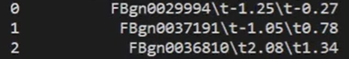

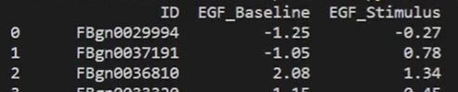

**1-3 Viewing and inspecting data with pandas**



How to clear the terminal

**1-4 Filter and sort with pandas**



apply function

lambada function

**1-5 Cleaning data with pandas**



表达式后面跟随的叫做flags

The inplace flag only confirms that we are applying the changes to the dataframe’s current instance just so we don’t have to write it equal to itself.



This should be replace all nan value with the string N/A

1. **Openpyxl**

**2-1 Introducing the Python openpyxl library**

Openpyxl: Package in python that allows code to interact directly with Excel documents.

Python openpyxl library

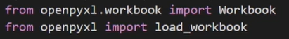

**2-2** **Using openpyxl with workbooks**

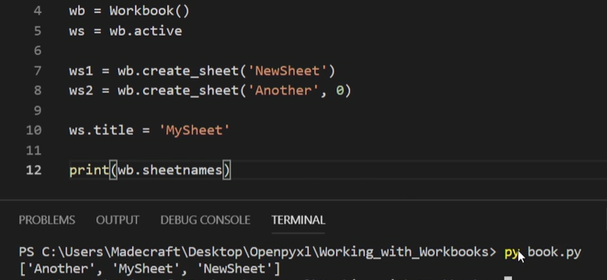

(‘Another’, 0) 0--- count as an index, so in the order of our worksheets this one appears before everything else.

The workbook contains 3 worksheets. ‘Another’ sheet is first because of our index zero, essentially we have just created two additional pages to work with on Excel, one cool optimization tidbit is that openpyxl won’t actually create cells on your worksheet as objects until they’re accessed. So creating and writing a new workbook like this doesn’t take too much memory.

Loading an existing workbook

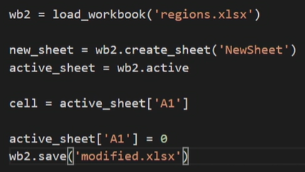

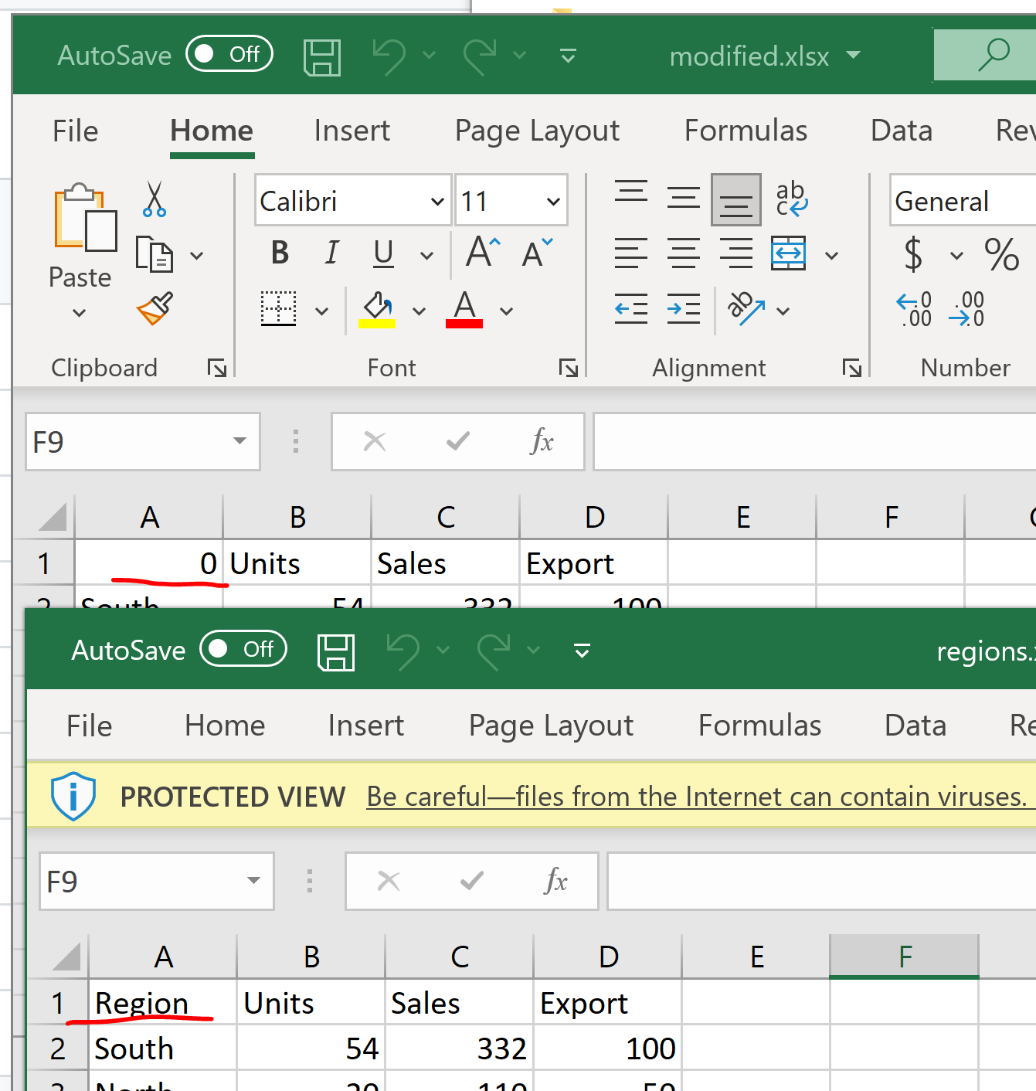

**2-3** **Selecting cells, rows, and columns**

The column value which is typically A through Z and the row value which starts at 1.

One way to index through the worksheet is by slicing.

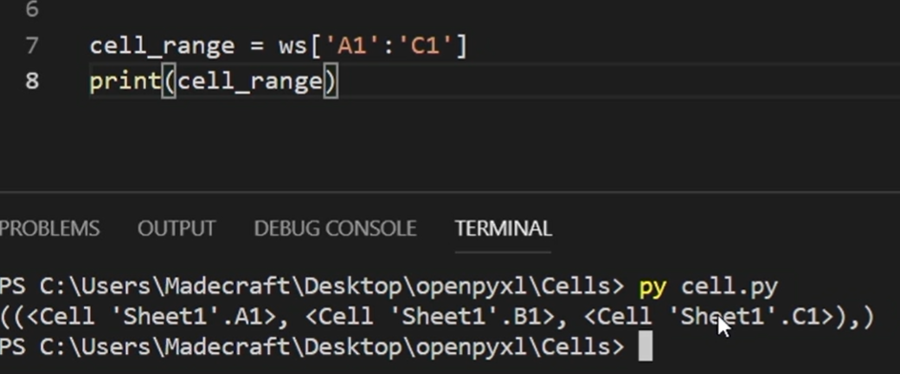

‘cell_range’ holds all the cells from column A row one to column C row one.

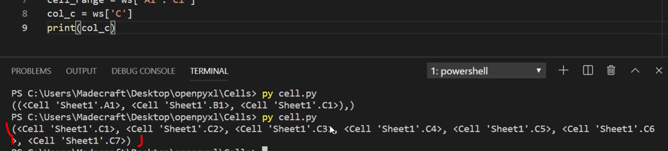

If we indexed at column C of 4, then we would return the cell C5.

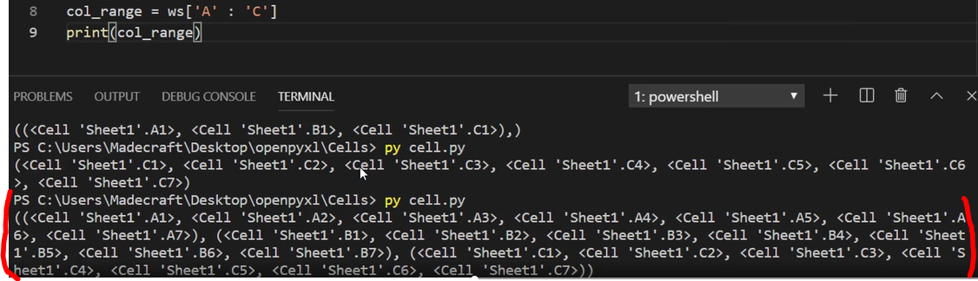

Because this is listing just columns, the first index corresponds to each column, while the second corresponds to each row. For example, if I want to access from the column range variable B2, I would index it at 1,1.

* Cells are accessed by the combination of string headers and integers
* Columns are only the headers.
* For rows we only use the integer.

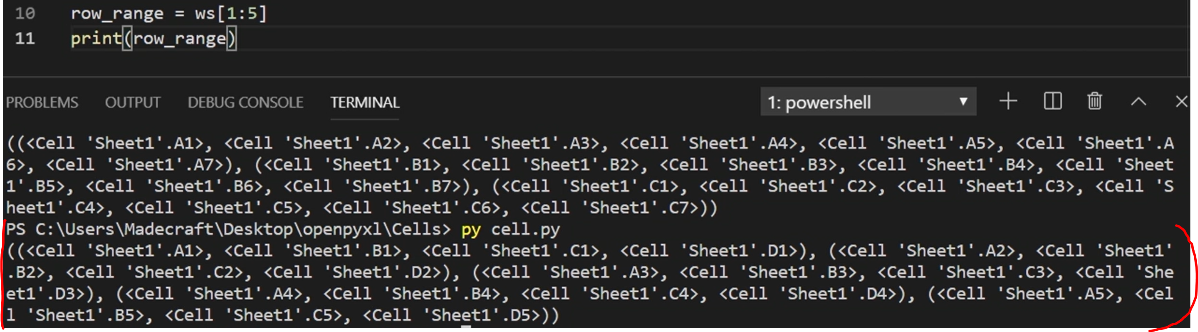

This time, the first index acts as the row index and the second acts as the column. For example, if I want to access B1, I would index it at 0,1.

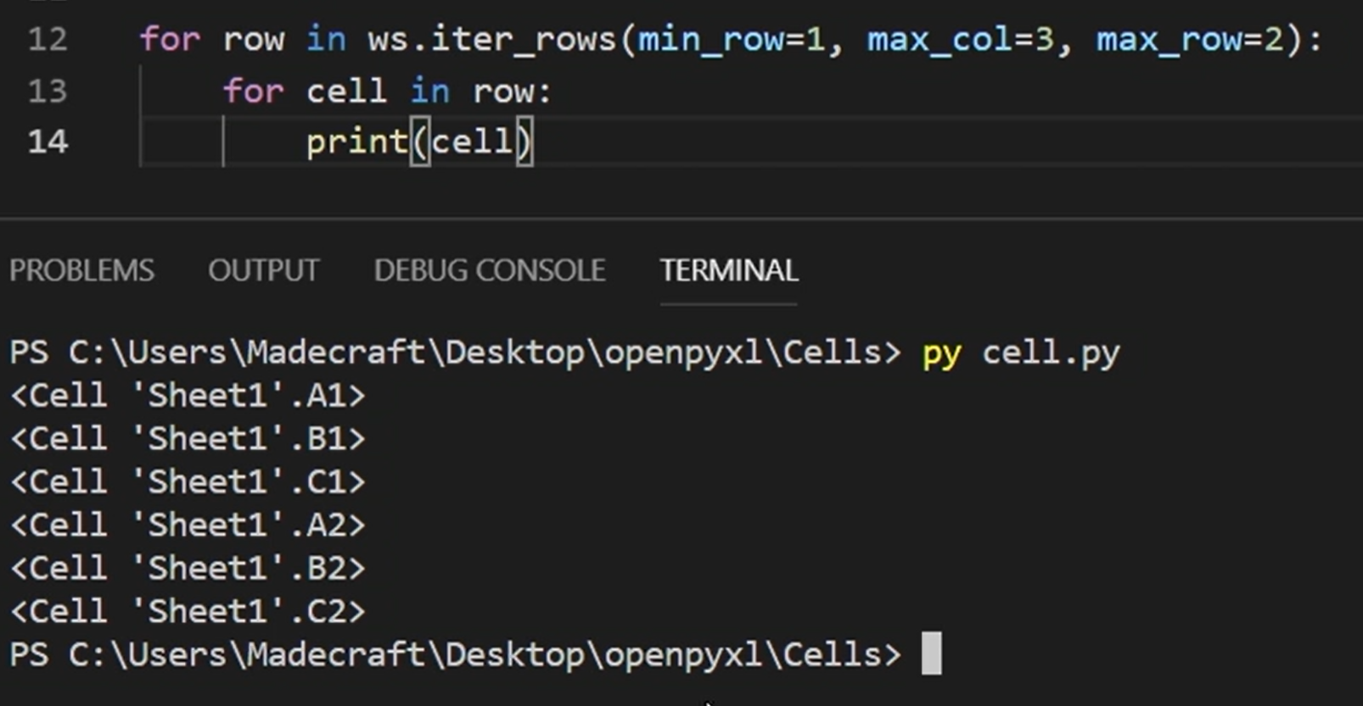

In the iter_rows or iter_columns function, we have to specify the minimum and maximums for our rows and columns.

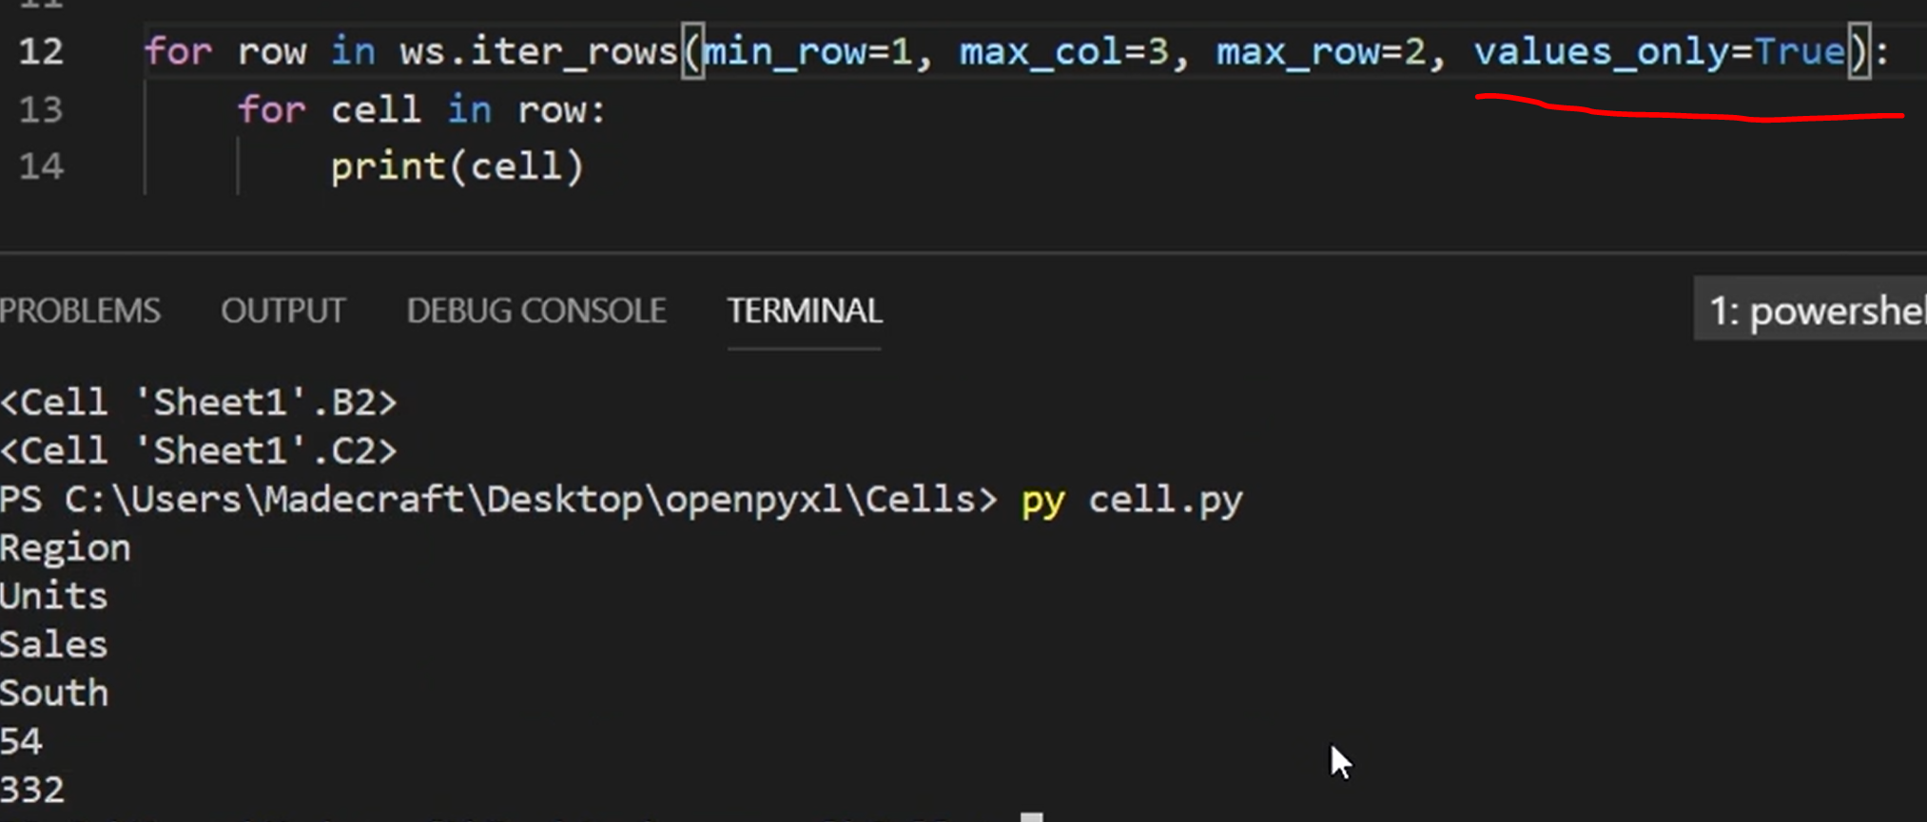

**2-4** **Formatting workbooks**

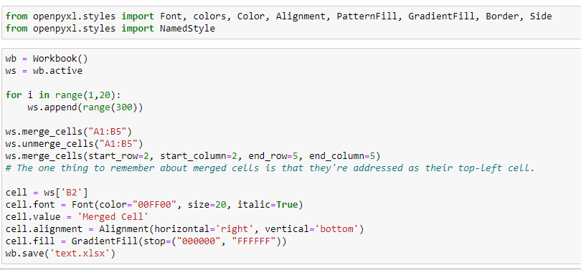

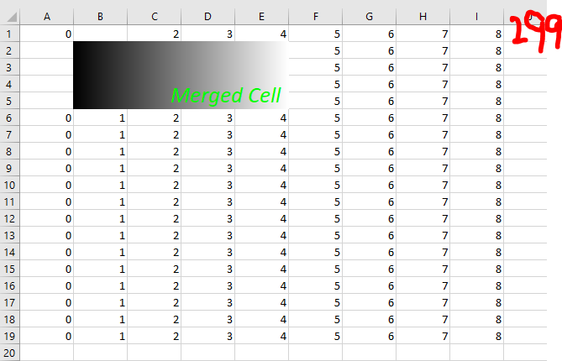

NamedStyle are objects we can create that store a style so that we can use it multiple times instead of having to type all that out.

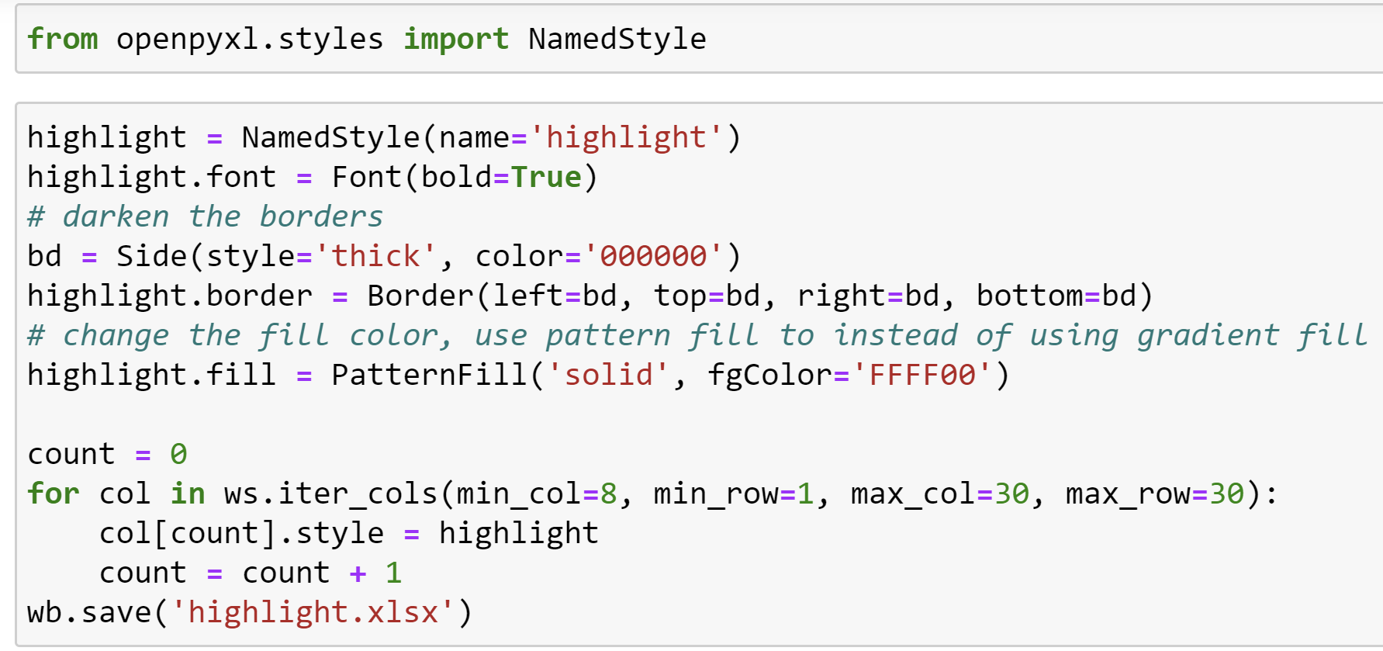

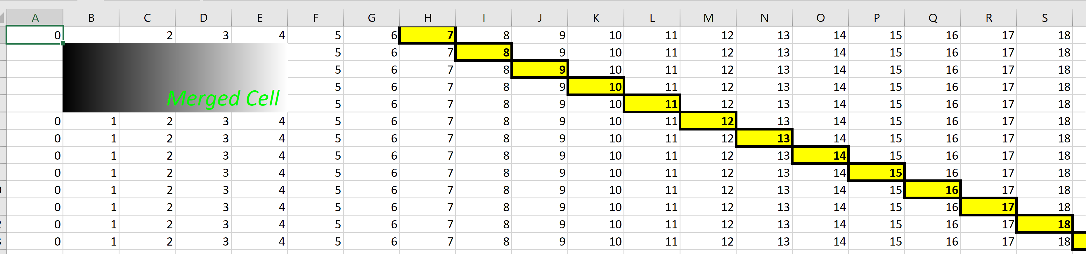

**2-5** **Graphs and charts**

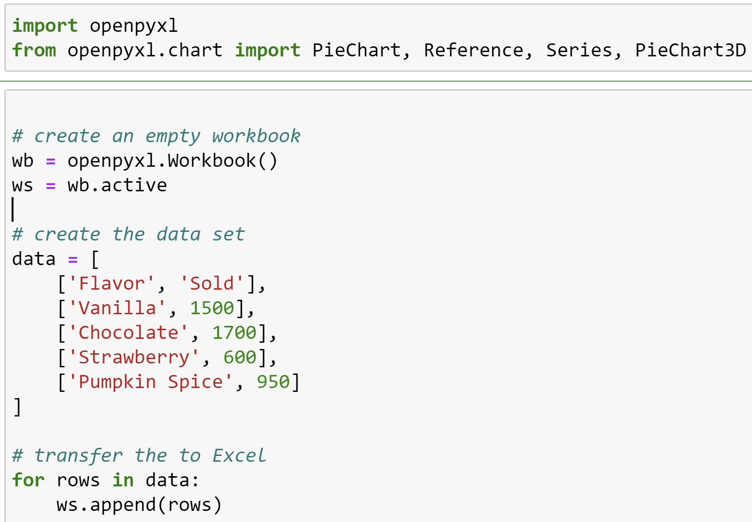

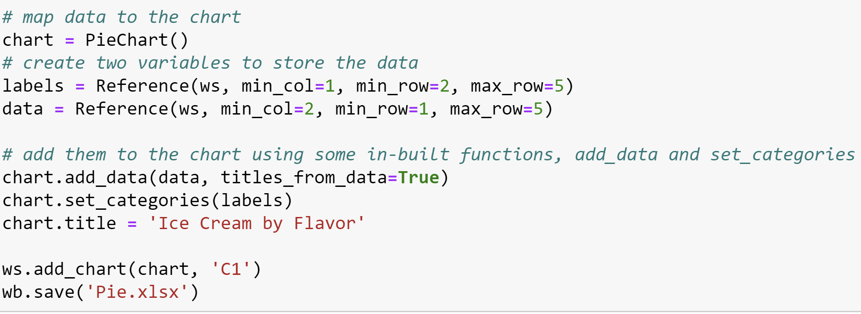

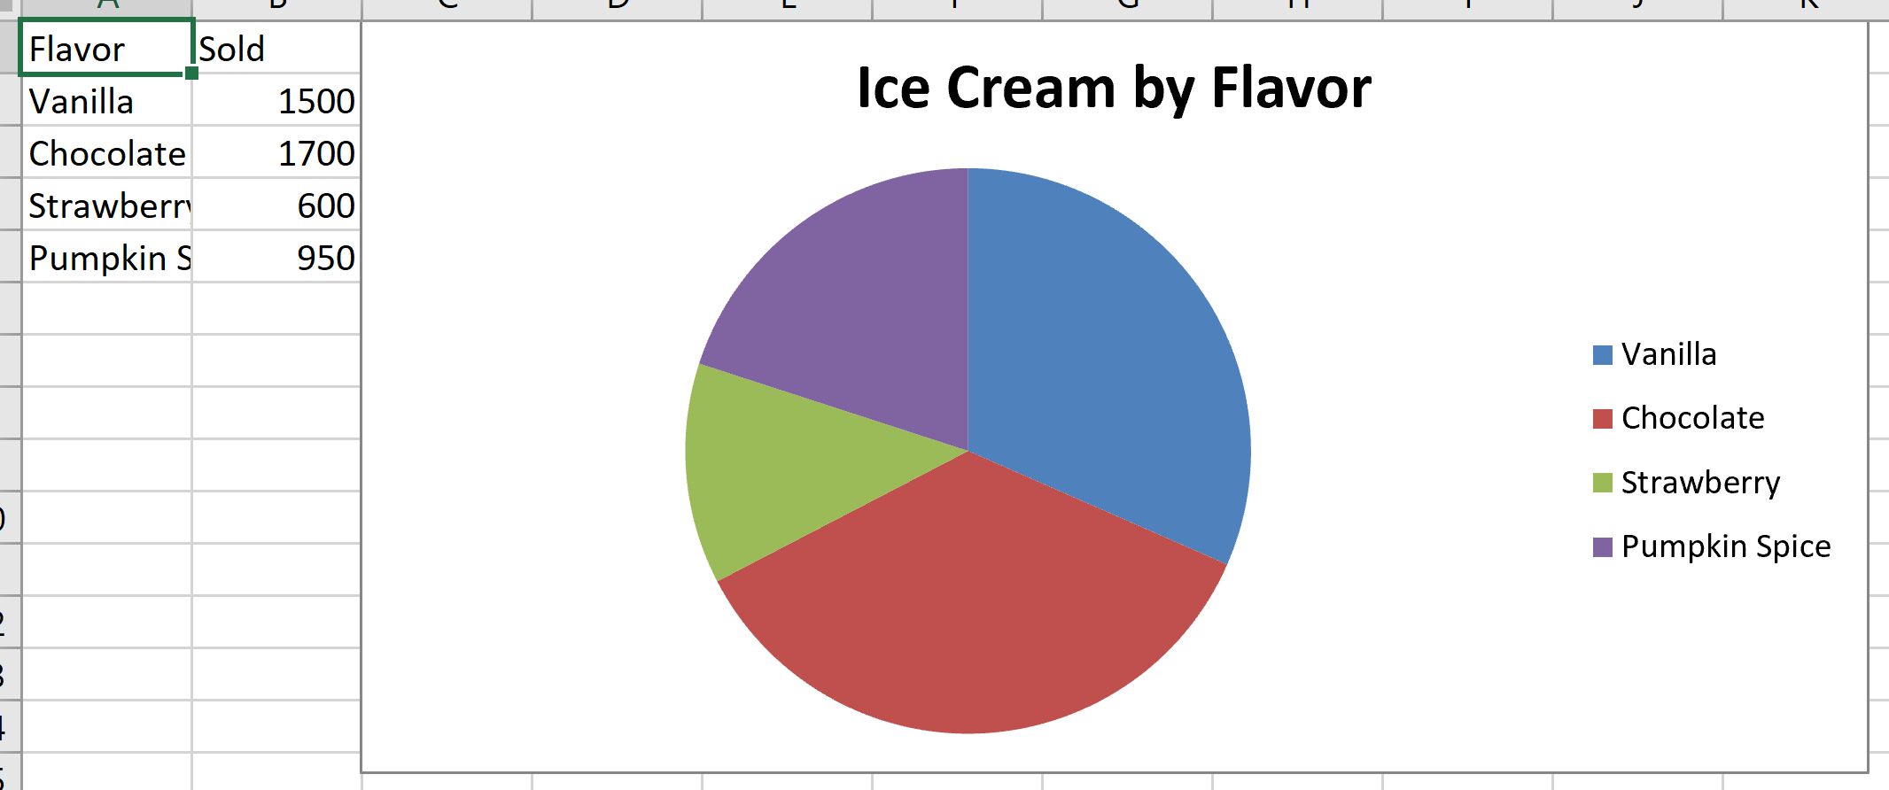

**2-6** **Tables and images**

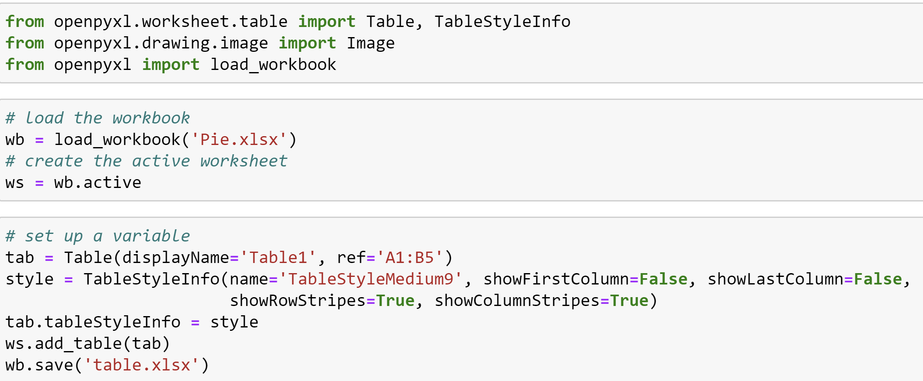

Or

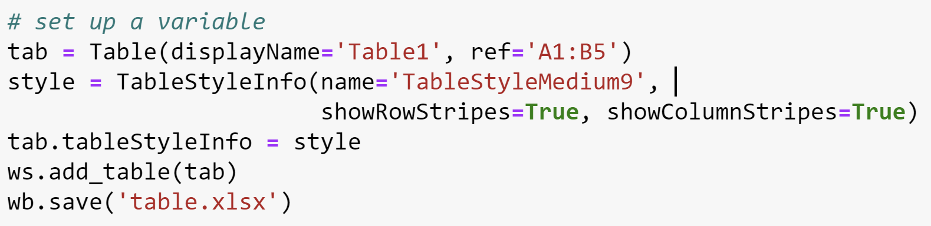

Get the same result.

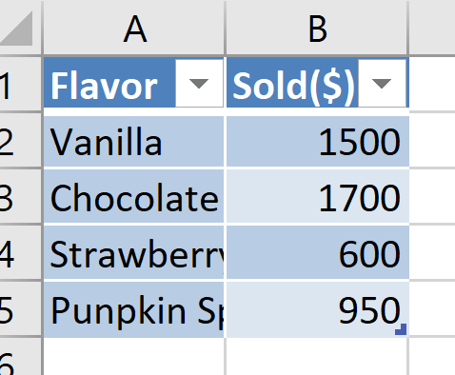

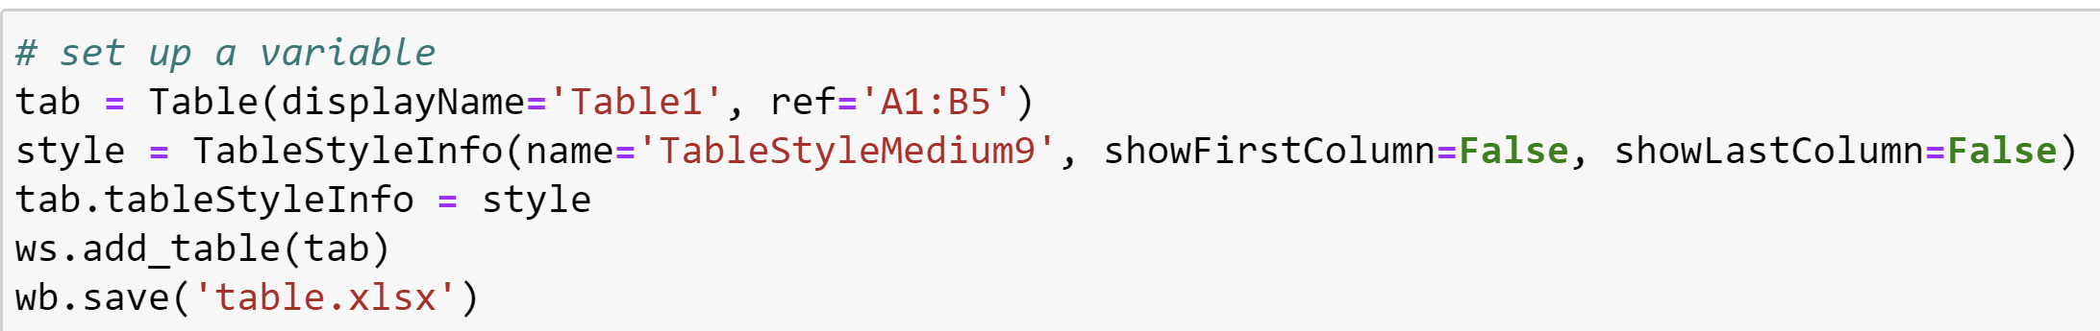

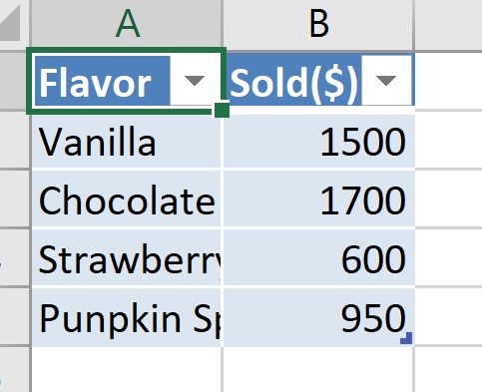

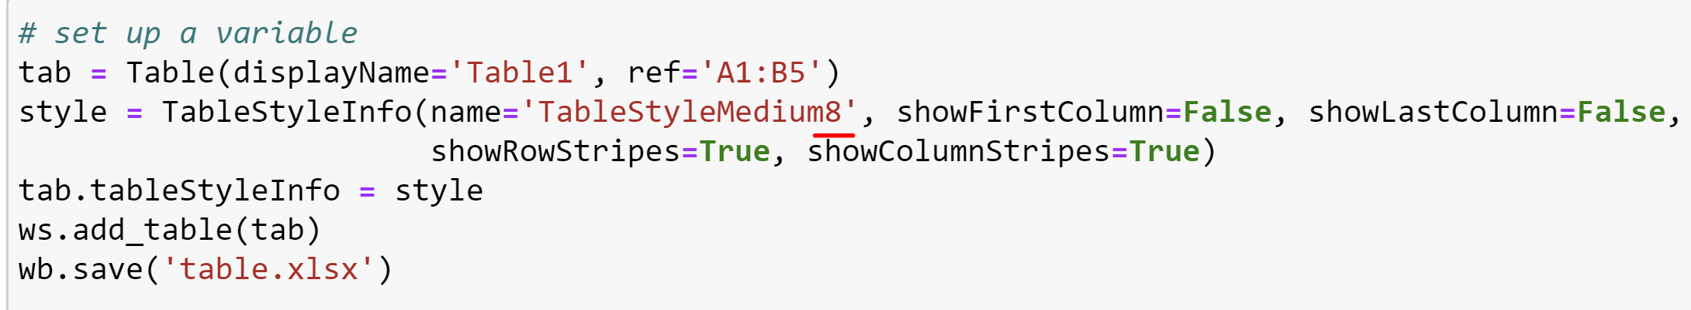

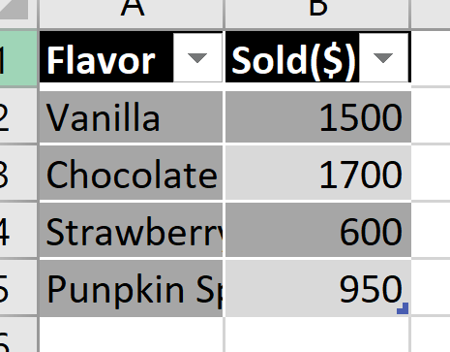

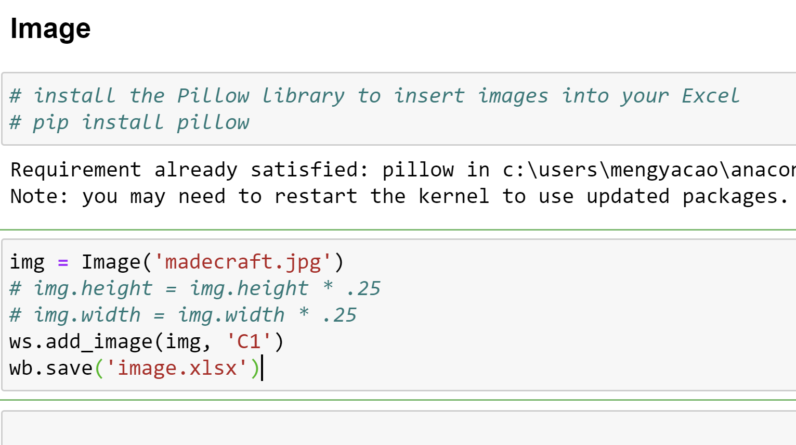

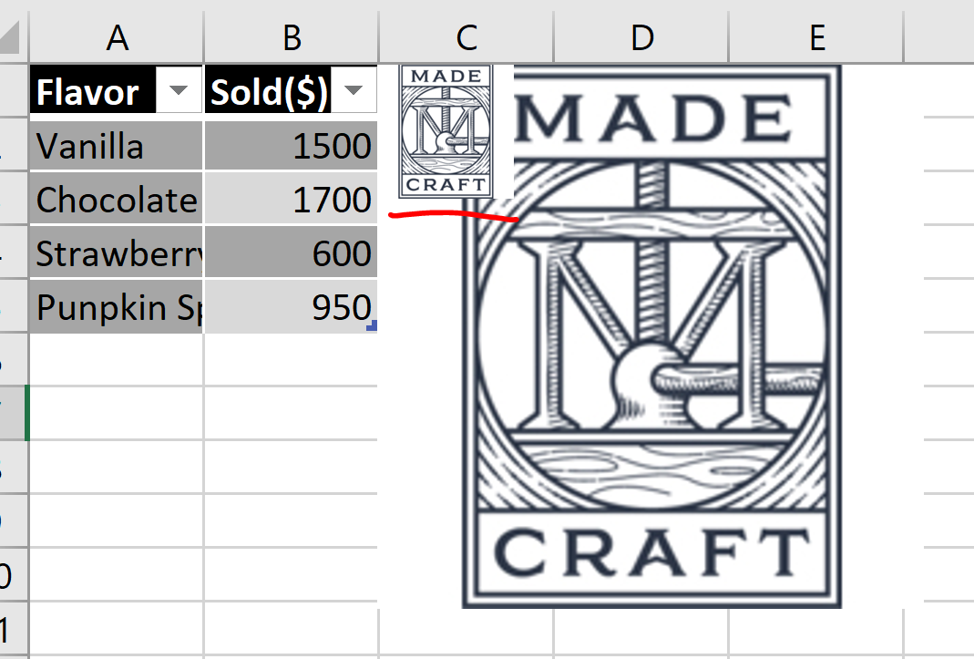

**3-2 Managing multiple sheets**

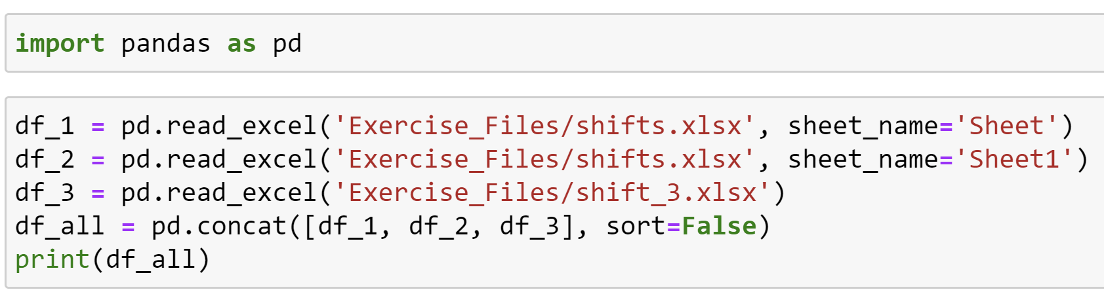

Concat function: This will combine all of the data frames as long as they have the same header columns.

Make sure to set sort=False so that the columns stay in the same order.

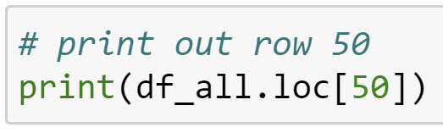

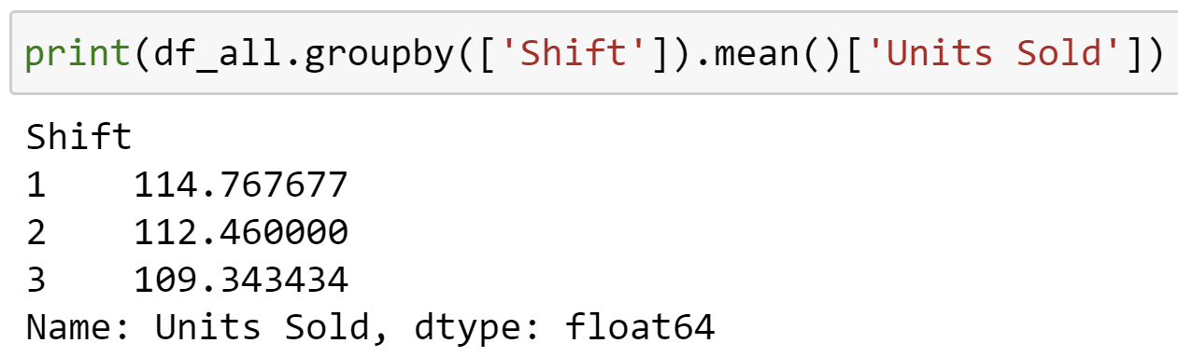

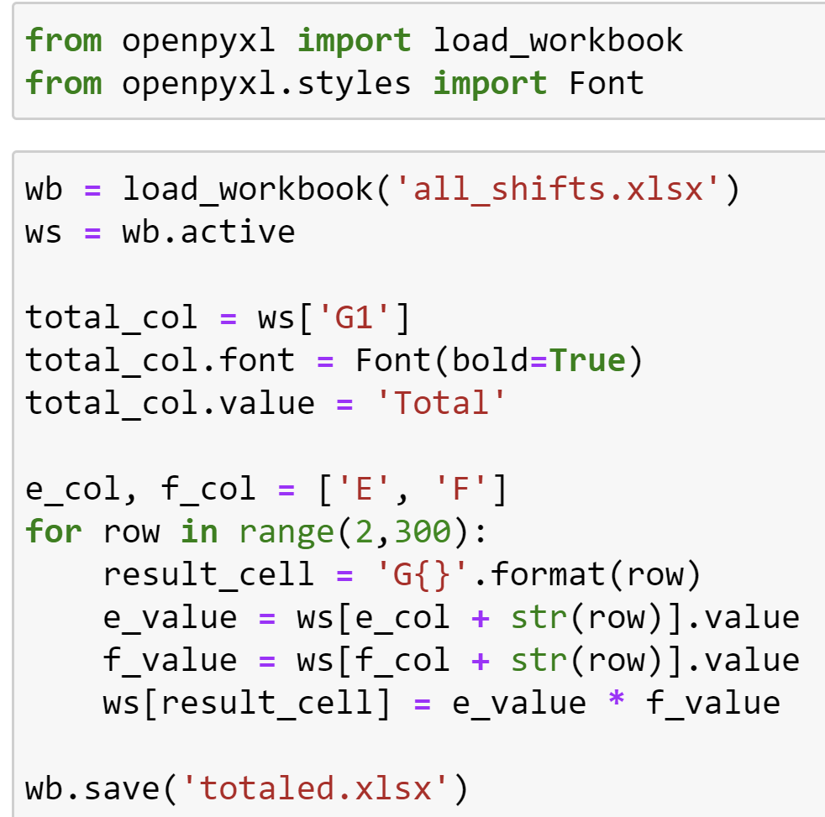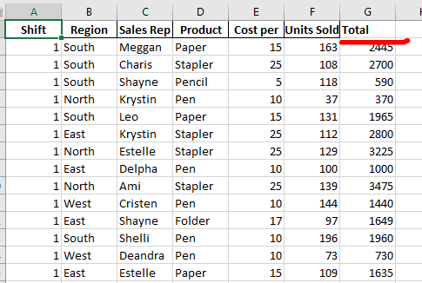

**3-3 Converting data**

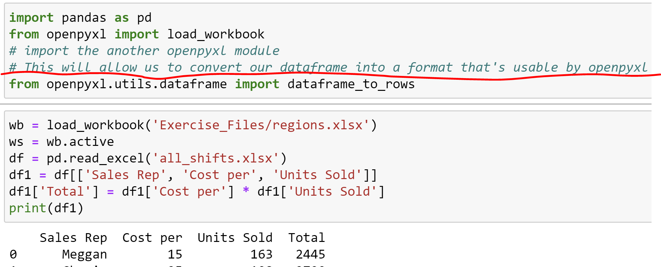

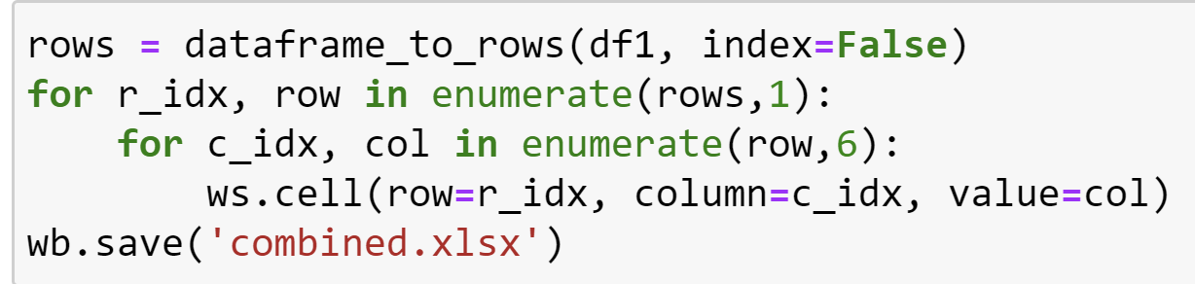

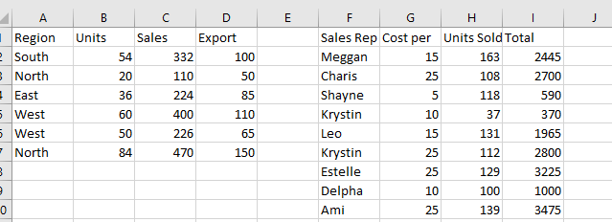

Enumerate

**3-4 Parsing large spreadsheet**

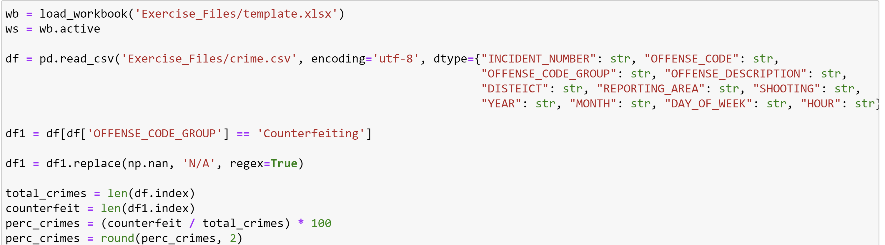

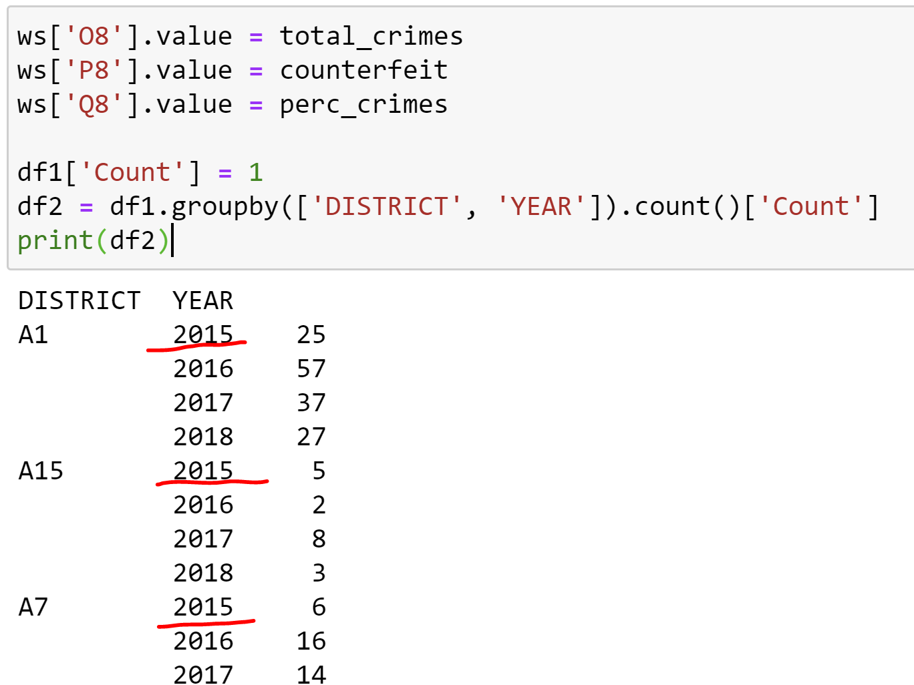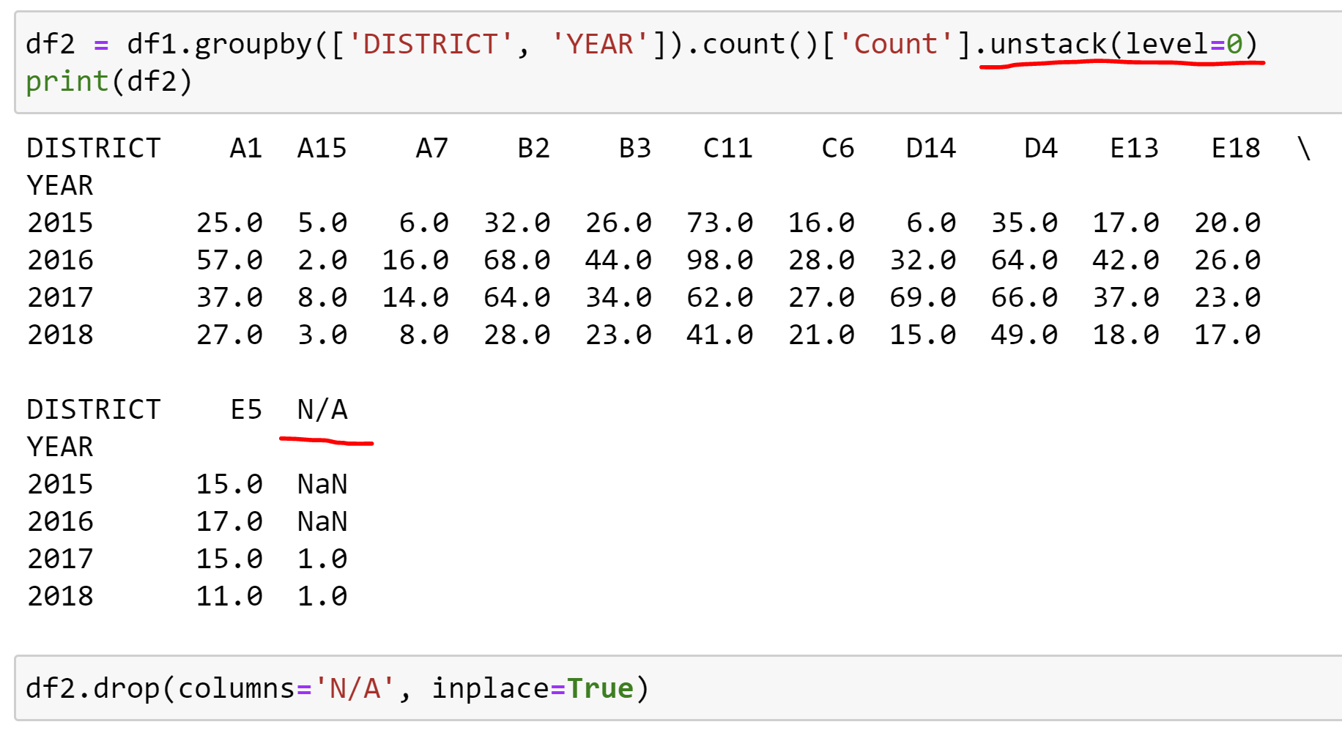

Unstack(level=0) will cause the dataframe to display its contents like a table.

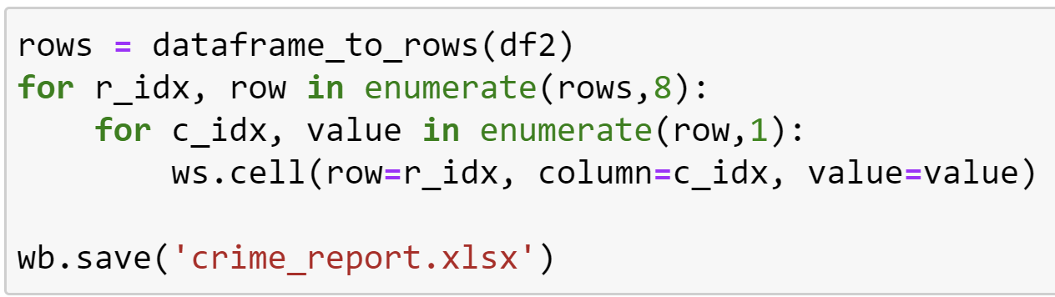

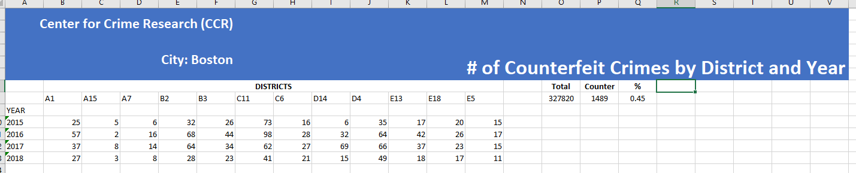

**3-5 Advanced graphing with Excel and Python**

